**Terraform challenge**

**Write a code using Terraform that deploys and achieves the following:-**

1. **Create an EC2 Instance on AWS Cloud using the below-mentioned ubuntu AMI and instance_type. Or, (You can use of your choice as well) ami = "ami-0461b1436c9b3c1a3" instance_type = "t2.micro"**
2. **Install a web server on the same EC2 Instance. The web server should listen on port 8080.**
3. **Create a Docker-compose file for the project:**[**https://github.com/betawins/cricbuzz-docker-hello-world.git**](https://github.com/betawins/cricbuzz-docker-hello-world.git)**and point it to port 8000.**
4. **Make the web server point to the above service so that 8080 returns the response from the Docker service.**
5. **Configure to Save the Logs in the location /var/log/cb.log**
6. **Write the Log rotate configuration for the above file**

**From the terraform iam going to create ubuntu server**

**AMI: ami-0360c520857e3138f**

**Instance Type: t3.micro**

**Create main.tf**

**provider "aws" {**

**region = "us-east-1"**

**}**

**# Data source to get the default VPC**

**data "aws_vpc" "default" {**

**default = true**

**}**

**# Data source to get a subnet from the default VPC**

**data "aws_subnets" "default" {**

**filter {**

**name = "vpc-id"**

**values = [data.aws_vpc.default.id]**

**}**

**}**

**# Data source to reference the existing security group**

**data "aws_security_group" "web_sg" {**

**name = "web_sg_unique"**

**vpc_id = data.aws_vpc.default.id**

**}**

**# EC2 Instance**

**resource "aws_instance" "web_server" {**

**ami = "ami-0360c520857e3138f" # Specified Ubuntu AMI**

**instance_type = "t3.micro"**

**key_name = "terraform-key" # Ensure this key pair exists in AWS**

**vpc_security_group_ids = [data.aws_security_group.web_sg.id]**

**subnet_id = data.aws_subnets.default.ids[0]**

**associate_public_ip_address = true**

**user_data = <<-EOF**

**#!/bin/bash**

**LOG="/var/log/cb.log"**

**echo "Starting user_data script at \$(date)" > $LOG**

**# Update & install dependencies**

**apt-get update -y >> $LOG 2>&1 || { echo "Failed to update packages" >> $LOG; exit 1; }**

**apt-get install -y nginx docker.io git curl logrotate >> $LOG 2>&1 || { echo "Failed to install packages" >> $LOG; exit 1; }**

**# Enable & start Docker**

**systemctl enable docker >> $LOG 2>&1 || { echo "Failed to enable Docker" >> $LOG; exit 1; }**

**systemctl start docker >> $LOG 2>&1 || { echo "Failed to start Docker" >> $LOG; exit 1; }**

**# Install Docker Compose**

**DOCKER_COMPOSE=/usr/local/bin/docker-compose**

**curl -L "https://github.com/docker/compose/releases/download/v2.20.2/docker-compose-$(uname -s)-$(uname -m)" -o $DOCKER_COMPOSE >> $LOG 2>&1 || { echo "Failed to download Docker Compose" >> $LOG; exit 1; }**

**chmod +x $DOCKER_COMPOSE || { echo "Failed to make Docker Compose executable" >> $LOG; exit 1; }**

**# Clone application**

**APP_DIR=/home/ubuntu/cricbuzz-docker-hello-world**

**mkdir -p /home/ubuntu**

**cd /home/ubuntu**

**if curl --output /dev/null --silent --head --fail https://github.com/betawins/cricbuzz-docker-hello-world.git; then**

**if ! git clone https://github.com/betawins/cricbuzz-docker-hello-world.git $APP_DIR >> $LOG 2>&1; then**

**echo "Failed to clone repository, creating fallback app" >> $LOG**

**mkdir -p $APP_DIR**

**cd $APP_DIR**

**# Fallback Dockerfile**

**cat <<EOD > Dockerfile**

**FROM python:3.9-slim**

**WORKDIR /app**

**RUN pip install flask**

**COPY . .**

**EXPOSE 8000**

**CMD ["python", "app.py"]**

**EOD**

**# Fallback Flask app**

**cat <<EOD > app.py**

**from flask import Flask**

**app = Flask(__name__)**

**@app.route('/')**

**def hello():**

**return 'Hello, World!'**

**if __name__ == '__main__':**

**app.run(host='0.0.0.0', port=8000)**

**EOD**

**else**

**cd $APP_DIR**

**# Check if Dockerfile and required files exist**

**if [ ! -f Dockerfile ] || ! grep -q "COPY ./hello_world" Dockerfile || [ ! -f hello_world ]; then**

**echo "Repository Dockerfile is missing or invalid, using fallback" >> $LOG**

**# Fallback Dockerfile**

**cat <<EOD > Dockerfile**

**FROM python:3.9-slim**

**WORKDIR /app**

**RUN pip install flask**

**COPY . .**

**EXPOSE 8000**

**CMD ["python", "app.py"]**

**EOD**

**# Fallback Flask app**

**cat <<EOD > app.py**

**from flask import Flask**

**app = Flask(__name__)**

**@app.route('/')**

**def hello():**

**return 'Hello, World!'**

**if __name__ == '__main__':**

**app.run(host='0.0.0.0', port=8000)**

**EOD**

**fi**

**fi**

**else**

**echo "Repository not accessible, creating fallback app" >> $LOG**

**mkdir -p $APP_DIR**

**cd $APP_DIR**

**# Fallback Dockerfile**

**cat <<EOD > Dockerfile**

**FROM python:3.9-slim**

**WORKDIR /app**

**RUN pip install flask**

**COPY . .**

**EXPOSE 8000**

**CMD ["python", "app.py"]**

**EOD**

**# Fallback Flask app**

**cat <<EOD > app.py**

**from flask import Flask**

**app = Flask(__name__)**

**@app.route('/')**

**def hello():**

**return 'Hello, World!'**

**if __name__ == '__main__':**

**app.run(host='0.0.0.0', port=8000)**

**EOD**

**fi**

**cd $APP_DIR**

**# Build Docker image**

**if ! docker build -t cricbuzz-local . >> $LOG 2>&1; then**

**echo "Docker build failed, attempting fallback build" >> $LOG**

**# Fallback Dockerfile**

**cat <<EOD > Dockerfile**

**FROM python:3.9-slim**

**WORKDIR /app**

**RUN pip install flask**

**COPY . .**

**EXPOSE 8000**

**CMD ["python", "app.py"]**

**EOD**

**# Fallback Flask app**

**cat <<EOD > app.py**

**from flask import Flask**

**app = Flask(__name__)**

**@app.route('/')**

**def hello():**

**return 'Hello, World!'**

**if __name__ == '__main__':**

**app.run(host='0.0.0.0', port=8000)**

**EOD**

**docker build -t cricbuzz-local . >> $LOG 2>&1 || { echo "Fallback Docker build failed" >> $LOG; exit 1; }**

**fi**

**# Docker Compose file**

**cat <<EOT > $APP_DIR/docker-compose.yml**

**version: '3'**

**services:**

**web:**

**image: cricbuzz-local**

**ports:**

**- "8000:8000"**

**restart: always**

**EOT**

**# Start container**

**docker-compose -f $APP_DIR/docker-compose.yml up -d >> $LOG 2>&1 || { echo "Failed to start Docker container" >> $LOG; exit 1; }**

**# Wait for app to be ready**

**sleep 60**

**# Verify Flask app is running**

**if ! curl --fail http://127.0.0.1:8000 >> $LOG 2>&1; then**

**echo "Flask app failed to start" >> $LOG**

**exit 1**

**fi**

**# Remove default Nginx site to avoid conflicts**

**rm -f /etc/nginx/sites-enabled/default >> $LOG 2>&1**

**# Configure Nginx to listen on port 8080**

**cat <<EOT > /etc/nginx/sites-available/cricbuzz**

**server {**

**listen 8080;**

**server_name _;**

**access_log /var/log/cb.log;**

**error_log /var/log/cb.log;**

**location / {**

**proxy_pass http://127.0.0.1:8000;**

**proxy_set_header Host \$host;**

**proxy_set_header X-Real-IP \$remote_addr;**

**proxy_set_header X-Forwarded-For \$proxy_add_x_forwarded_for;**

**proxy_set_header X-Forwarded-Proto \$scheme;**

**}**

**}**

**EOT**

**# Link Nginx configuration**

**ln -sf /etc/nginx/sites-available/cricbuzz /etc/nginx/sites-enabled/cricbuzz >> $LOG 2>&1 || { echo "Failed to link Nginx config" >> $LOG; exit 1; }**

**# Configure logrotate for /var/log/cb.log**

**cat <<EOT > /etc/logrotate.d/cricbuzz**

**/var/log/cb.log {**

**daily**

**rotate 7**

**compress**

**delaycompress**

**missingok**

**notifempty**

**create 0640 www-data ubuntu**

**postrotate**

**/usr/sbin/nginx -s reload**

**endscript**

**}**

**EOT**

**# Test and restart Nginx**

**if ! nginx -t >> $LOG 2>&1; then**

**echo "Nginx configuration test failed" >> $LOG**

**exit 1**

**fi**

**systemctl restart nginx >> $LOG 2>&1 || { echo "Failed to restart Nginx" >> $LOG; exit 1; }**

**systemctl enable nginx >> $LOG 2>&1 || { echo "Failed to enable Nginx" >> $LOG; exit 1; }**

**# Test logrotate configuration**

**logrotate -d /etc/logrotate.d/cricbuzz >> $LOG 2>&1 || { echo "Failed to test logrotate config" >> $LOG; exit 1; }**

**echo "user_data script completed successfully at \$(date)" >> $LOG**

**EOF**

**tags = {**

**Name = "Cricbuzz-Web-Server"**

**}**

**}**

**# Output the public IP of the EC2 instance**

**output "instance_public_ip" {**

**value = aws_instance.web_server.public_ip**

**}**

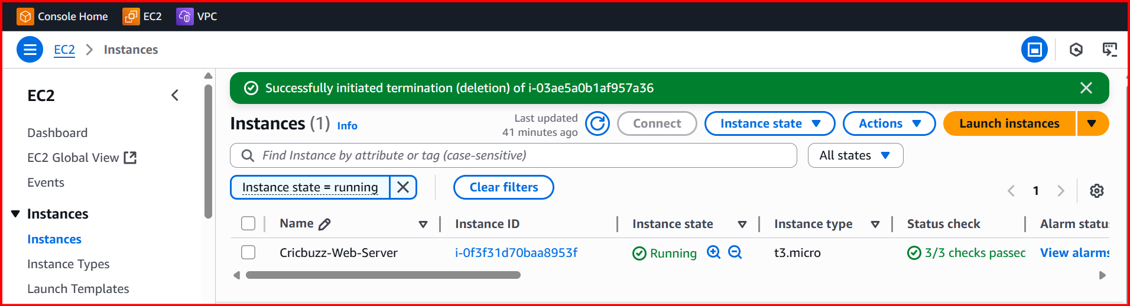

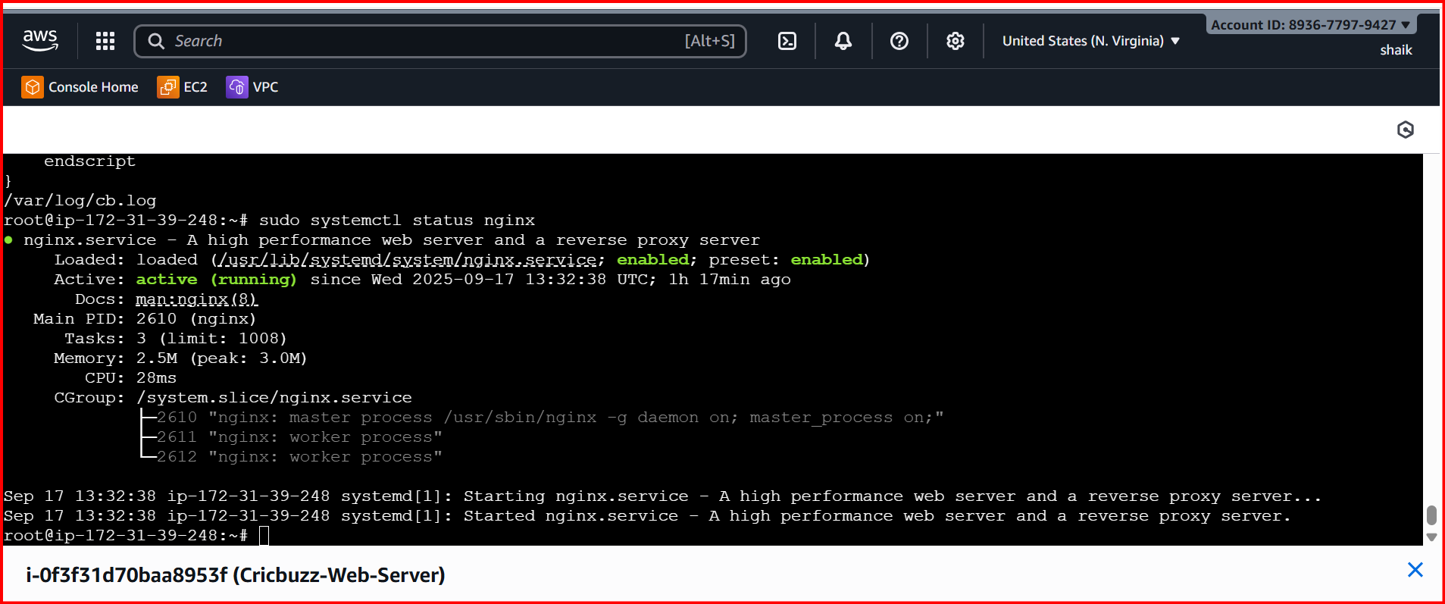

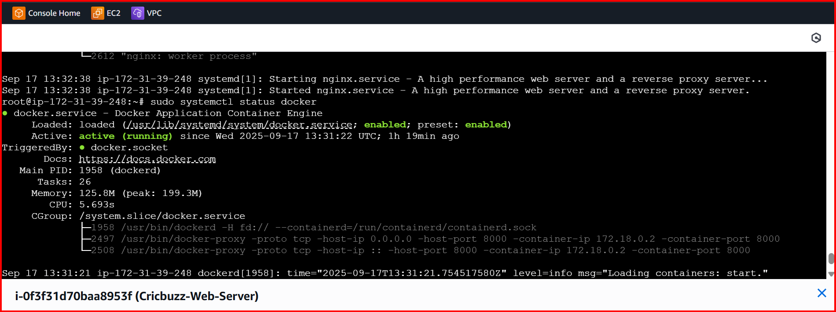

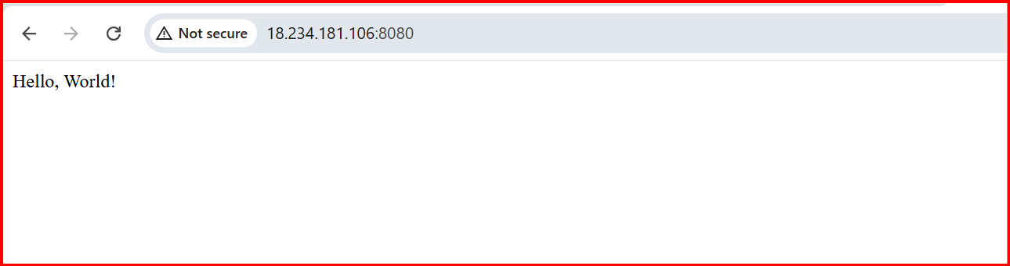

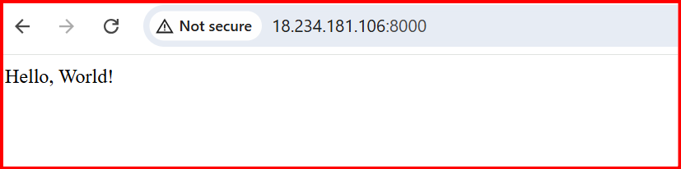

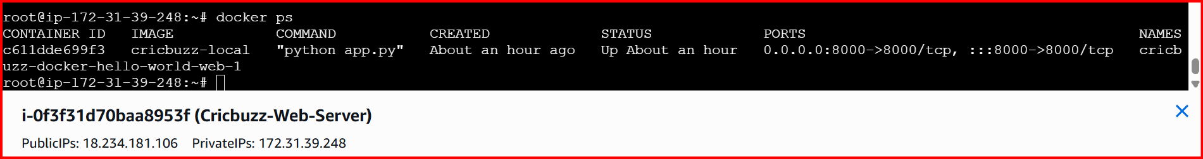

**5.Configure to Save the Logs in the location /var/log/cb.log**

**From root location**

**cd /var/log/**

**cat cb.log**

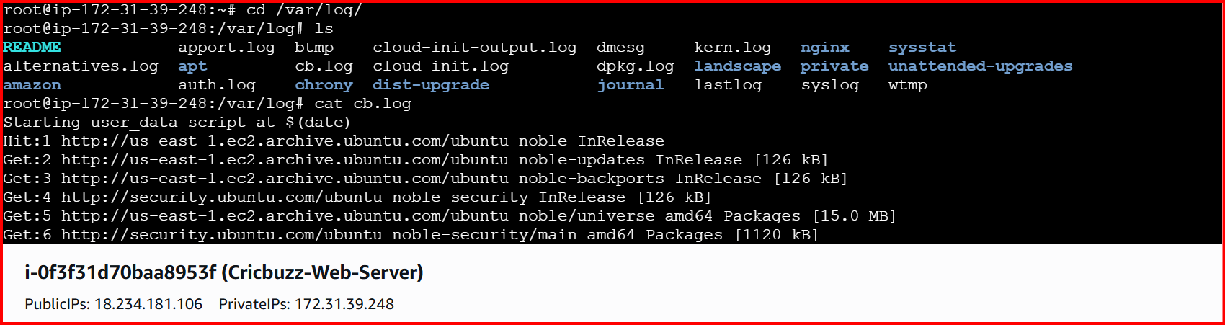

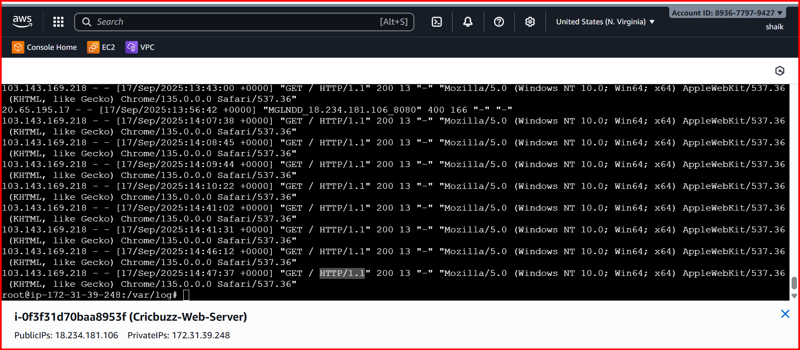

**Write the Log rotate configuration for the above file**

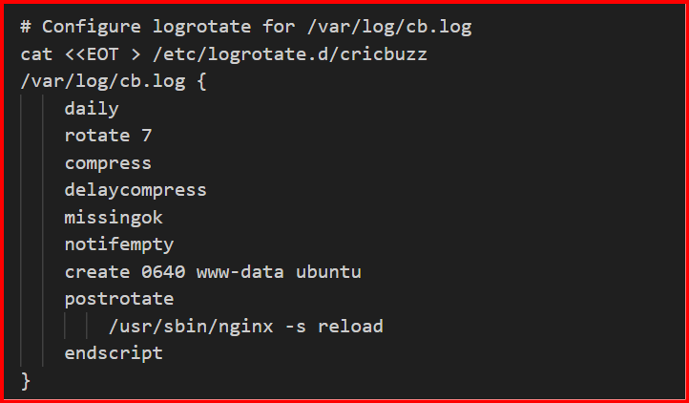

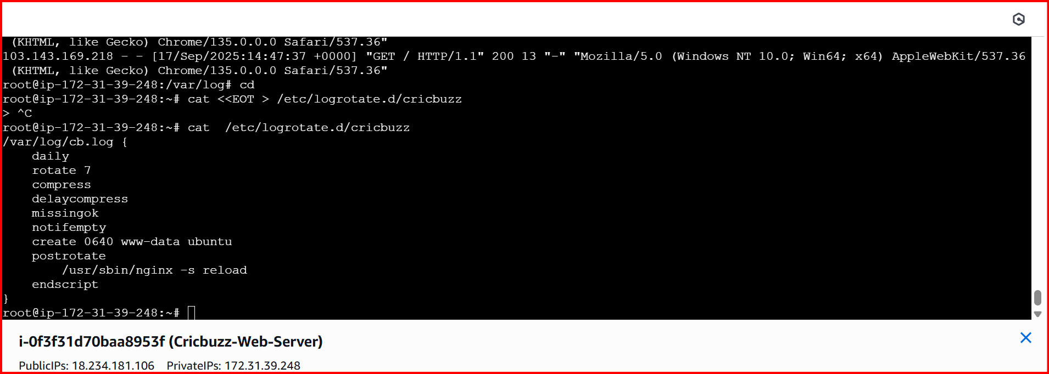

**This Terraform task sets up a web application on AWS using an EC2 instance. Here's why it's useful in simple terms:**

1. **Creates a Server Automatically:** 
   * **It launches an AWS EC2 instance (a virtual server) with Ubuntu and a t3.micro type (small, cost-effective).**
   * **Terraform automates this, so you don’t have to manually set up the server, saving time and avoiding mistakes.**
2. **Runs a Web Server (Nginx):** 
   * **Installs Nginx to listen on port 8080, acting as the front door for your web application.**
   * **Use: Lets users access your app via a web browser or API call on port 8080.**
3. **Deploys a Docker App:** 
   * **Clones a project (cricbuzz-docker-hello-world) and runs it in a Docker container on port 8000.**
   * **If the project has issues (like missing files), it uses a backup Flask app that says "Hello, World!".**
   * **Use: Docker makes the app easy to run, update, or move to other servers.**
4. **Connects Nginx to Docker:** 
   * **Nginx forwards requests from port 8080 to the Docker app on port 8000.**
   * **Use: Users visit http://<server-ip>:8080 and see the Docker app’s response, keeping the backend secure.**
5. **Saves Logs to /var/log/cb.log:** 
   * **All setup steps (installing software, running Docker) and Nginx activity (access and errors) are logged to /var/log/cb.log.**
   * **Use: Helps you check what’s happening on the server and fix issues (e.g., why something failed).**
6. **Manages Logs with Logrotate:** 
   * **Rotates /var/log/cb.log daily, keeps 7 days of logs, and compresses old ones to save space.**
   * **Use: Prevents the log file from getting too big, making it easier to manage long-term.**

**Why Is This Task Useful?**

* **Quick Setup: Automates setting up a web server and app, ready to use in minutes.**
* **Learning: Teaches you how to use Terraform, AWS, Docker, and Nginx together.**
* **Debugging: Centralized logs (/var/log/cb.log) make it easy to find and fix problems.**
* **Scalable: You can modify it for bigger apps or more servers later.**
* **Reliable: The fallback Flask app ensures the app works even if the GitHub project fails.**

**Logrotate Configuration**

**As you specifically asked for the logrotate part, here it is in simple terms:**

* **It manages the /var/log/cb.log file by:** 
  + **Creating a new log file daily.**
  + **Keeping only 7 days of logs.**
  + **Compressing old logs to save space.**
  + **Ensuring Nginx keeps working after rotation.**